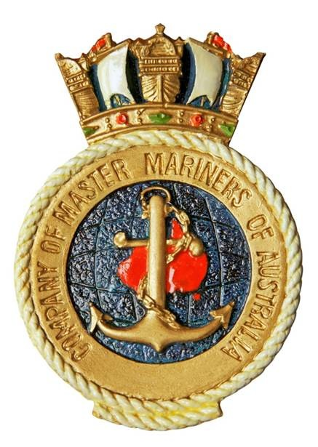

NEXT MEETING
POSTPONED DUE TO
COVID-19
- From the Branch Master
- Tom Hanks AMP Award
- Spanish Flu
- HMNZS AOTEAROA
- New President of N.I.
Hon. Sec., Alexandra Evered
Email alex@baysideshipping.com
Tel 03 5424 1224
In this issue:
The Log
The Monthly Newsletter of the Melbourne Branch of
The Company of Master Mariners of Australia Limited

Kindly Sponsored by:
Victorian Regional Channels Authority
Melbourne Branch
The Log

August 2020
From the Branch Master

The commemorative service for the 78th anniversary of Operation Pedestal which was to be held at the Shrine of Remembrance on Sunday 16th August had to be cancelled because of the COVID -19 restrictions. Instead the Shrine Governors produced a live stream service which was first broadcasts on the day. The service which runs for about 10 minutes starts with a series of photos of Malta and the convoys with a voice over relating the story of Operation Pedestal. This is followed with a wreath laying, the Last Post, a minutes silence and the National Anthem.
The service can be viewed at www.facebook.com/shrineofremembrance/video
It is expected a similar service will be produced for Merchant Navy Day on the 3rd September. The Seafarers Church Service at St Paul’s Cathedral on the 18th October will be another casualty of the virus and the organising committee are planning a virtual service. Details will be advised when they come to hand.

In last month’s LOG I reported on the problems involved in arranging seafarer’s repatriation when their contracts have ended. Cases of crews downing tools and refusing to sail have spread to Australia.
Currently there are three ships in Australian ports that have asked the International Transport Workers Federation to assist them in obtaining repatriation for crew members who have exceeded their contract period of service. One containership and two bulk carriers are refusing to sail.
While some seafarers battle to go on leave others struggle to get paid. On 27th July AMSA banned the bulk carrier “ Agia Sofia” from Australia for 6 months because it was found that some crew members had not been paid their full wages since August 2019. The total outstanding wages was $45,000
Three days later AMSA banned the bulk carrier “TW Hamburg” from Australia for 12 months. Unpaid wages amounted to $42,000 and the quantity and quality of food was well below the MLC standard as was the standard of cleanliness and hygiene in the galley and fridges. Some seafarers has expired employment contracts and requested repatriation

Tom Hanks wins AMP award

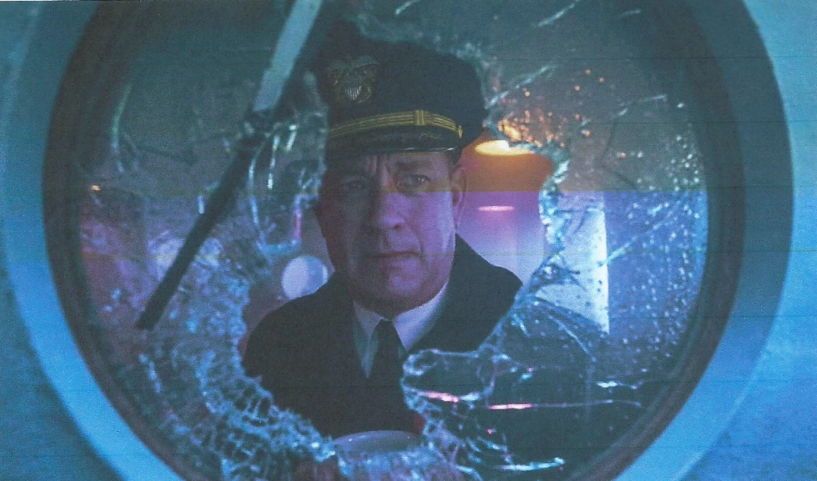

The American Maritime Partnership (AMP) has named Oscar winning actor Tom Hanks the recipient of the American Maritime Hero Award.
The AMP is a coalition of companies and organisations involved in the US domestic maritime industry. Its members come from all sections of the industry including ship owners and operators, shipbuilding and repair yards, ship board and shore side workers and trade and national security organisations. AMP believes that a strong domestic maritime industry is best supported by maintaining the Jones Act as the foundation of America’s domestic maritime policy.
The award recognises individuals or groups who have added to the United States heritage as a maritime nation through their professional contributions, courage, outstanding achievements or noble qualities.
The AMP said Hanks has drawn attention to the bravery of maritime heroes by staring in the film “Captain Phillips” narrating the documentary “Port Lift- an untold tale of 9/11 resilience” and writing the screen play and staring in the movie “Greyhound”
The movie was adapted from C.S. Forester’s 1955 novel “The Good Shepherd” which tells the story of a North Atlantic convoy under attack from a wolf pack of German Submarines
Spanish Flu

Cruise ships like “Ruby Princess” played a small role in the spread of COVID-19 but 100 years ago troop ships carried the Spanish Flu to all parts of the world.
The 1918-19 Influenza Pandemic infected an estimated 500 million people, about 1/3 of the world’s population and killed about 50 million.
There is no universal consensus on where it originated but it certainly was not Spain. One theory is that it started in China and was carried by Chinese labourers who passed through North America on their way to work in Europe behind the French and British lines. Amongst the first recorded cases was the outbreak at Camp Funston in Kansas. Camp Funston was a major training ground for troops of the American Expeditionary Forces and these troops introduced the virus to Europe.
ss “Leviathan” departed Hoboken New Jersey with 9000 troops and by the time it reached France 2000 were infected and 80 had died.
When WW1 ended the troops returning home carried the virus with them and eventually no part of the world was free of the sickness.
The first infected ship to enter Australia was the ss “MATARAM” which arrived in Darwin on 18th Oct 1918. Over the next six months the quarantine service intercepted 323 vessels of which 174 carried the infection and 1,102 out of 81,510 people checked were infected.
The troop ship HMAT “Barambah” departed Australia in September 1918 and had an outbreak of influenza off the West Coast of Africa which killed 20 soldiers and 4 RAN personnel. The RAN suffered 284 deaths during WW1 and one in six of these was due to the Influenza pandemic.
The last troop ship to leave Australia for the Western Front was HMAT “Boonah”. It docked in Durban to news the war was over so it returned to Australia. Spanish Flu was rampant in South Africa and the disease was transmitted on to the ship when locals loaded stores on board for the voyage home. By the time the ship reached Fremantle 300 of the 1200 troops on board had contracted influenza. The sick were transferred to hospital and the ship was quarantined at anchor in Gage Roads. 27 soldiers and 4 medical staff died.

Quarantine stations were set up at North Head in Sydney, Point Nepean in Victoria, Bruny Island in Tasmania, Torrens Island in South Australia, Woodman Point in Western Australia and Lytton in Brisbane. Maritime quarantine played a major role in containing the spread of the virus. Between December 1918 and September 1919, 147 troopships carrying 160,000 military personnel returned from Europe and the Middle East.
Two million or 40% of Australia’s population of 5 million became infected and 15,000 died but it was less than a quarter of the 62,000 service personnel who died as a result of the war. Australia’s death rate of 2.7 per 1000 of population was one of the lowest recorded by any country during the pandemic.
New Zealand has a higher death rate. In August 1918 HMNZT “Tahiti” with a crew of 100 and 1117 military personnel on board became infected while loading stores in Freetown Sierra Leone. Over 800 became sick and 77 died.
From New Zealand the virus was spread to the Pacific Island by the Union Steamship Company ship “Talune” which was engaged in the New Zealand / Pacific Island trade. There were outbreaks in Fiji, Tonga, Nauru and Samoa where 20% of the population died.
The Commonwealth Serum Laboratories developed a pneumonic influenza vaccine and over 3 million doses were given to returning service men and to the civilian population. The vaccine was partially effective and by closing state borders, wearing masks and a ban on large gatherings the pandemic was over by the end of 1919.

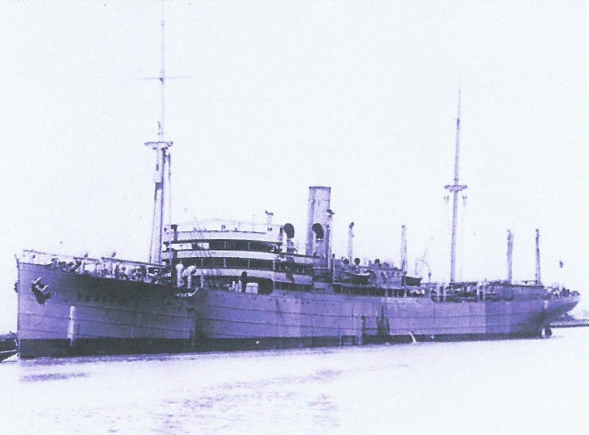

HMAT A36 BOONAH
“AOTEAROA”

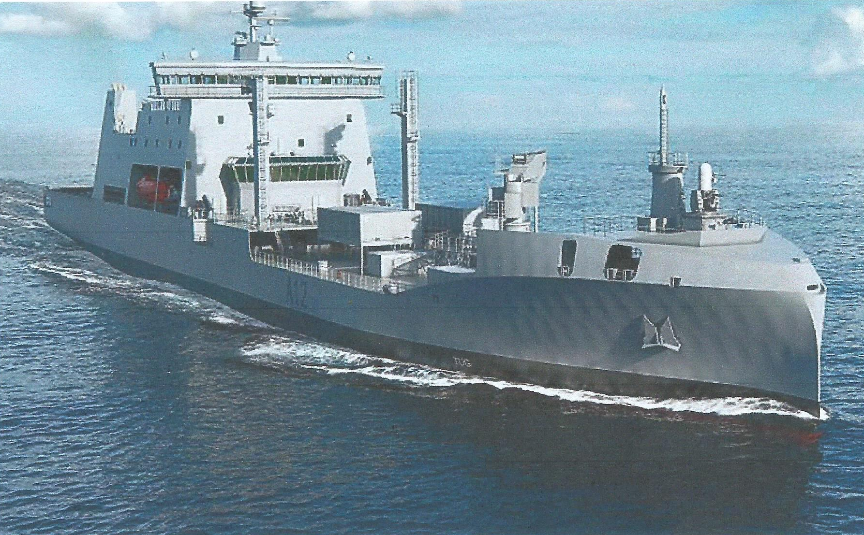

The New Zealand’s latest and largest ship is the logistics support and replenishment ship HMNZS Aotearoa.
The ship was built to the Rolls Royce environship concept design with a wave piecing bow which reduces resistance and lowers fuel consumption.
The multipurpose vessel will be used to support combat operations, humanitarian relief functions and operational and training support through the resupply of ship and aviation fuel, dry goods, water, spares and ammunition.
Aotearoa is ice strengthened to Polar Class level 6 so can resupply McMurdo Station and Scott Base and carry out Antarctic monitoring operations.
The 26,000 ton ship was built by Hyundai Heavy Industries in Ulsan South Korea and will replace the fleet tanker Endeavour which decommissioned in December 2017 after more than 30 years’ service.

New President for N.I.

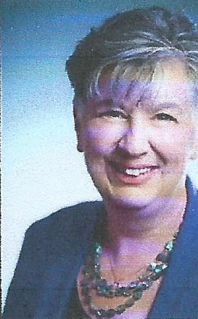

The newly elected President of the Nautical Institute is Jillian Carson-Jackson a member of the South East Australian Branch.
Jillian graduated from the Canadian Coast Guard College as a Navigation Officer. After working both afloat and ashore she spent 10 years as an instructor at the college.
Following an active role at IALA in the development of VTS Training she moved to France to work with IALA as Technical Coordination Manager. Her next move was to Australia as Manager of Vessel Traffic and Pilotage Services with AMSA.
In 2018 Jillian set up her own consultancy focusing on technical advice and education.
During her term as President, Jillian aims to help the Institute meet three important challenges – those of diversity and inclusion, branch engagement and managing the impact of technology.

