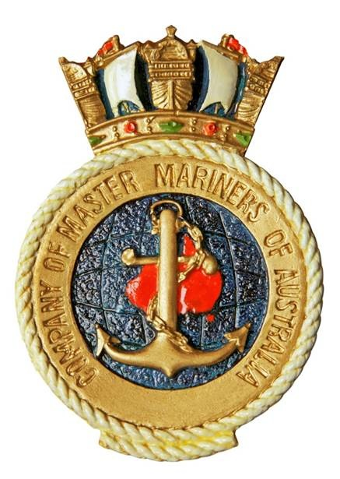

NEXT MEETING
ZOOM MEETING ON 28th OCTOBER
International crew changes and COVID-19
Speaker Alexandra Evered
- From the Branch Master
- The Honourable Company of Master Mariners
- Ultimate Navigator

Hon. Sec., Alexandra Evered
Email alex@baysideshipping.com
Tel 03 5424 1224
In this issue:
The Log
The Monthly Newsletter of the Melbourne Branch of
The Company of Master Mariners of Australia Limited

Kindly Sponsored by:
Victorian Regional Channels Authority
Melbourne Branch
The Log

October 2020
From the Branch Master

We held our first Zoom Branch Meeting on the 30th September and although only 9 members participated it was a success and demonstrated that Zoom meetings are viable and should be continued until our regular meetings are able to be resumed.
I opened the meeting with a report on the recent Federal Court Meeting. The main matters coming out of that meeting were:
- The Governor General has agreed to be our patron. Membership certificates for those who joined in the last year have been sent to the G.G. for signing.
- COMMA and the Nautical Institute are making joint efforts to promote ourselves as professional bodies and getting greater recognition in the media.
- Our membership is now only 364 which is 17 down on this time last year. It is suggested that we should try to attract more associate members.
- The W.A. Branch has arranged for the Leeuwin Foundation to produce a trial edition of the Master Mariner Magazine in November. If the magazine meets our requirements and can be produced at an acceptable cost it is hoped to have at least two editions each year.
- This year’s Federal Budget allowed for the cost of a face to face federal AGM and other expenditure items that did not occur. There should be a fairly large surplus and this may be able to be passed on to the branches by way of a reduced Federal levy next year.

Ross Brewer speaking in his capacity as a Director of the Melbourne Maritime Heritage Network gave us a very interesting talk on the recent activities and proposals to preserve and promote Melbourne’s maritime heritage. They are keen to see the establishment of a Maritime Precinct in Docklands. He mentioned that the Yarra Strategic Plan had no mention of Maritime Heritage but following representations from MMHN the consultants employed by the State Government for the reactivation of Docklands will include maritime heritage in their report.
The Melbourne City Council will conduct a feasibility study and business case for the redevelopment of the Mission to Seafarers building. The redevelopment proposed would cost the Government between $10 million and $20 million.
It would include improved facilities for seafarers and upgraded kitchen and dining areas so that it could produce an income. There would be an area to display shipping memorabilia.
Seafarers Rest Park will be developed over the next couple of years along with the Riverlee Project. The old transit shed is being refurbished and the wharf crane has been restored.
MMHN is concerned about Vic Ports lack of planning for a catastrophic event and the lack of consistency in the management structure of Victoria’s ports. MMHN would like to see greater use made of the river and bay by watercraft.
Ross mentioned the proposed maritime precinct at Williamstown. BAE are expected to move their remaining facilities from Williamstown to Fisherman’s Bend.
There is concern for Polly Woodside because the National Trust is suffering financially because 80% of its income comes from the entrance fees into its heritage buildings and that has stopped due to Covid-19.
MMHN would like to see a maritime centre developed. It could be at the Mission to Seafarers Building but Ross would prefer a purpose built building at the end of the currently condemned Centre Pier.
Ross said their activities have been restricted by COVID-19 but look forward to next year particularly if Jackie Watts is re-elected to the Melbourne City Council.
-----------------------------------------------------------------------------------------------------------
Next Zoom Meeting
28th October 1800 for 1830
Speaker Alexandra Evered
International Crew Changes and COVID-19
---------------------------------------------------------------------------------------------------------------------
Last month the September edition of “Seatimes”, the newsletter of the Nautical Professional Education Society of Canada, was made available to members. The newsletter contained articles on a variety of subjects including the crew change crisis, pilotage of ultra large container ships and life on great lakes freighters during COVID-19 but it was the reproduction of the stowage plan of a general cargo ship that attracted the attention of at least two of our members.
Detlef Koepke wrote from Tasmania “very good to see an old style general cargo stowage plan again, cannot count the number I created in the times before containers took over liner service with Hamburg America Line (now HapagLloyd). You drew the plan on a special copy paper then pressed it into a moist sort of rubber mat and let it sink in. Afterwards you
took the original off (always with the help of the apprentice or 3rd Mate) and placed a blank stowage plan on the rubber: after a little while the plan was taken off”
“This way copying was done during those years, there were no copy machines around on ships”
Francis Castellino remembers “In my day cargo plans had to be drawn by hand. We had only general cargo ships with one or two tween decks which meant hundreds of individual parcels of cargo loaded from six or seven ports in Europe for discharge in four or five ports in India and on the reverse voyage too. The senior cadet was in charge of maintaining a running plan (drawn by hand on A1 size paper) from loading plans received from the respective stevedores. Once all loading was completed, each cadet was given two blank plans and we all had to sit around the master plan and copy it. Needless to say, due to human error, some parcels would be left out from a plan here or there and needless to say the cadet involved would have to turn to all night to make up for his sins.”

------------------------------------------------------------------------------------------------------------------------
Recently it became apparent to me that many of us, myself included, knew very little about the organisation on which COMMA was based. While doing the research for the following article on The Honourable Company of Master Mariners I realized that we are very much the poor cousins. They hold their functions on the “Wellington” with its grand staircase and timber panelling and its collection of marine paintings, artefacts, gold and silver plate, ship models and 18th century charts. Befitting these elegant surrounds on formal occasions members of the court dress in their Livery Gowns and regalia. It’s not that they do things better than us but they do it with more style.

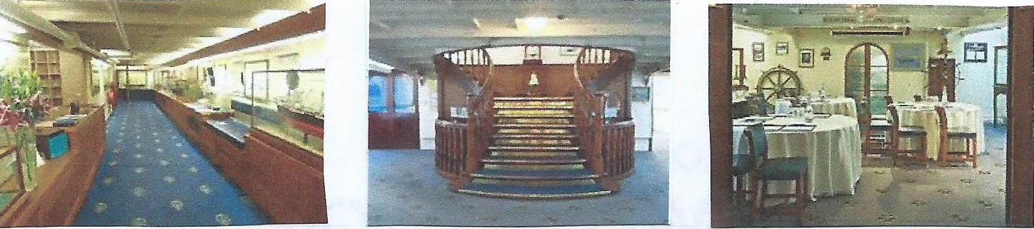
The Honourable Company of Master Mariners

During the annual shipmasters dinner in Liverpool in 1921 the Member of Parliament for Wallasey, Sir Robert Burton-Chadwick, suggested that Master Mariners were entitled to form their own Guild or Company along the lines of the City of London Livery Companies.
As a result of his efforts and encouragement the Company of Master Mariners was formed on 25th June 1926
Two years later King George V bestowed the title “Honourable” on the Company in recognition of the great loss of life suffered by the Merchant Service during WW1. The title “Honourable” had only previously been given to two companies. The Honourable East India Company and the Honourable Artillery Company. The title has now also been bestowed on the Honourable Company of Air Pilots.
In 1932 The Court of Aldermen confirmed on the Company the status of Livery. It was the first time in 240 years that a new company had been admitted. The Honourable Company of Master Mariners became the 78th in order of precedence.
Livery Companies are the London craft or trade associations that are the descendants of the medieval guilds. Livery Companies used to strictly control the training and entry into trades and the way they conducted their business. Today with a couple of exceptions they no longer have that level of control and are involved in supporting trade, education, charity and fellowship.
They have a role in the election of the Sheriffs and the Lord Mayor of the City of London. Since the Master Mariners joined another 32 companies have been admitted. These modern Livery Companies usually come from the professions such as solicitors, air pilot, engineers and accountants.
It had been the Honourable Company’s ambition to have a Livery Hall but the cost in the City of London was prohibitive. In 1947 the Grimsby class sloop Wellington became available and it was bought with money subscribed by the members.
The cost of converting it into a floating Livery Hall came from contributions from Lloyds, shipping Companies, Livery Companies and benefactors.
HMS Wellington served in the Pacific, particularly in New Zealand, before the war. Most of its war service was on convoy escort duties in the North Atlantic.
The ship has a number of rooms of various sizes and is beautifully appointed. It can be hired for private functions such as weddings and for corporate receptions for up to 220 guests.
The Honourable Company has its headquarters on HQS Wellington but also has outposts in the major maritime cities of Britain.

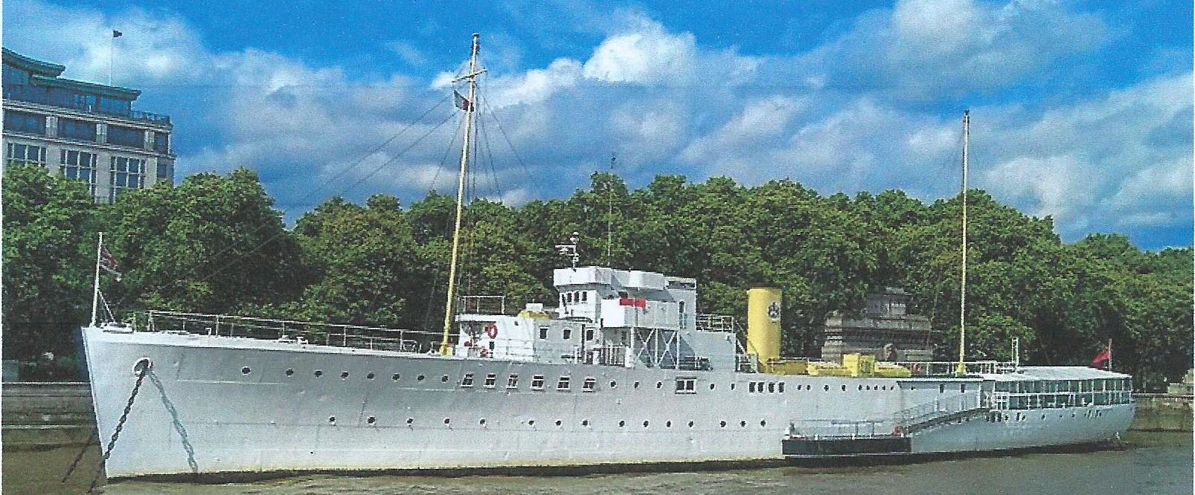

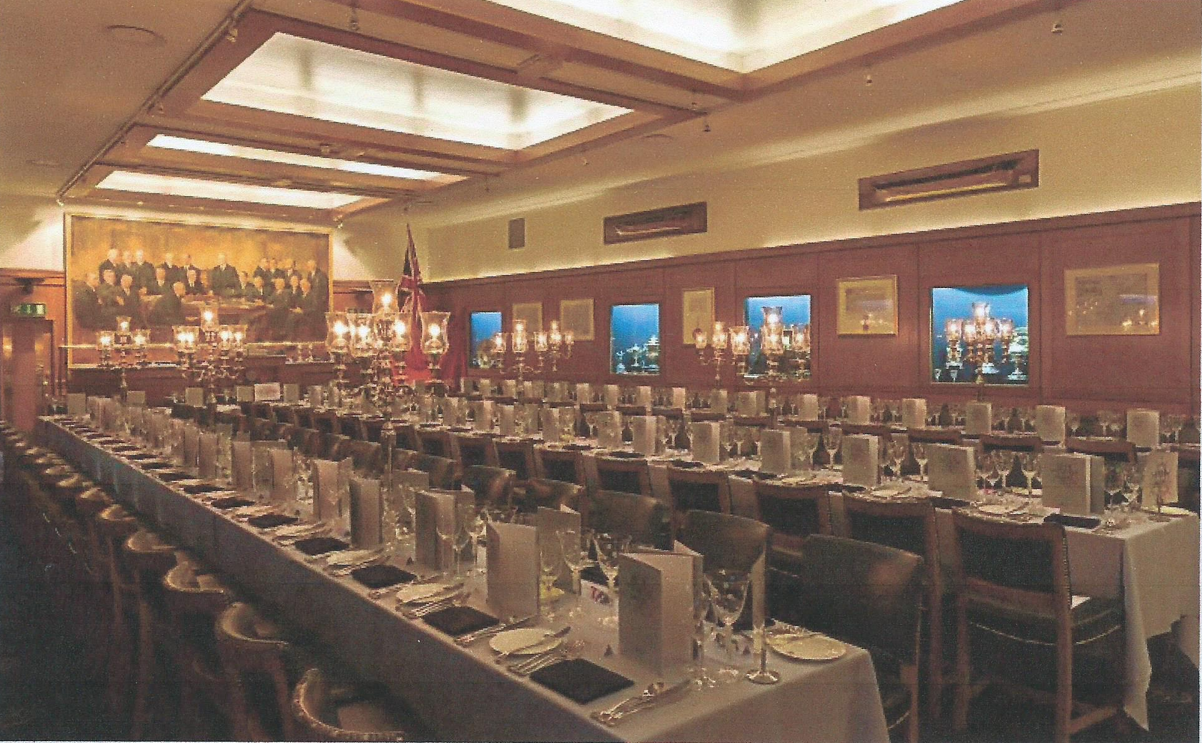

Ultimate Navigator

This article appeared in the Obituary section of the New York Times on Aug 29th 2020

Marvin Creamer Died on August 12th
The first man known to have sailed round the globe without using instruments was 104

When Francis Drake rounded the globe in 1577-80, he took an astrolabe, compass and cross-staff with him. As Ferdinand Magellan, the first known circumnavigator, started out in 1519, he had at least an astrolabe and compass. But when Marvin Creamer set sail from Cape May, New Jersey in 1982, into thick overcast and a howling gale, on a voyage of 30,000 miles requiring nearly a year at sea, he carried to his delight no instruments at all.
Well, to be accurate, there were a few. He had an hourglass, the only time-keeper, to mark the watches of his small crew. Down in the bilge, in a duffel bag, were a radio, sextant, compass and clock, in case of emergency. His wife Blanche, with whom he had had months of lively discussions about the voyage- she dead against him sailing off, he, at 66, desperate to go – had insisted on this. But he had it sealed by the navy, intending never to get those “toys” out, and never did. Lastly, there was a transmitter somewhere on the Globe Star to give the little cutter-rigged sloop’s position regularly to the coast guard. But it did not tell him where he was, and that was vital. He was going by the stars.
The ancient sailors he so admired, the Vikings and Chinese traders, as well as more modern Polynesians, had gone the same way. None of them, as far as known, had circled the globe, but it seemed to him that they might have made predictable landfalls, setting a course and then returning again. He meant to prove, and never had much doubt - 5% perhaps – that they could also have got further. Endurance or fame were not the point of this endeavour, which even he admitted looked insane. It was the intellectual challenge of finding out how the ancients might have done it.
To prepare himself he had done some hard study of oceanography and meteorology, in the gaps between teaching geography in the department he had founded at Glassboro State College, now Rowan University. And he had gone seafaring, first fishing on small outboards past the barrier islands off New Jersey, where he would venture out so far that his colleagues thought him either lost, or mad, and later sailing across the Atlantic to Ireland and Africa. It was on a voyage back from the Azores in 1974, when he had taken the dark-to-daylight watch and the compass-light kept failing that he looked up and thought why not? All he had to do at that moment was find Polaris, the Pole Star, put his shoulder in line with the keel, and steer straight on. It worked like a dream.
Star-steering had intrigued him since childhood, when his farmer-father taught him to observe the different positions of the setting sun from the south-west corner of the barn. On his voyage a clear view of sunset or sunrise could tell him his position, but for latitude without a sextant he needed to make a geometry of the night sky, drawing an imaginary line between Polaris and his chosen navigation star and watching where that star made its meridian transit. Finding a fixed point in the southern hemisphere was tricky until he learned to use Acrux and Gacrux, two of the brightest stars in the Southern Cross, as pointers to the southern celestial Pole. (Delta Orionis, right over the celestial Equator, was most useful for longitude) Both north and south of the Equator, his calculations proved so accurate that almost all the Globe Star’s landfalls on the route from Dakar via Sydney round to Bermuda were within 15 miles of the target, and close to the dates he’d set.
Yet for much of the voyage he could not see the night sky at all. Crossing the Pacific, they had five sights of the stars in 5,000 miles. To estimate latitude and direction he had to be fiercely observant in daylight too. He watched the sea most: its deep swell, the surface interaction of new waves with old ones, and the shadows they cast , its colour, whether blue in the deep or green in plankton filled waters, and the wake of the boat. He guessed the Globe Star’s speed from the time bubbles took to move from bow to stern. His log showed that, having veered off the Horn in fog and with no landmarks, he was unsure whether they had rounded it or not. But he thought they had because the sea had gone from a dark transparent green to a lighter green then turned dark again – the colour an old mariner had told him, of the Atlantic.
He guessed they had too from the sudden icy breath of a north wind coming off the snow covered Andes. The wind was always a useful indicator. Leaving Cape May, he had set course south-east for Senegal by keeping the freezing north-westerly at the midpoint of the back of his neck. After days in the doldrums, floating with no direction, the sudden nail-scraping squeak of a hatch told him that a dry wind was blowing up from Antarctica. Heavy cumulus clouds indicated land, diving petrels showed specifically the Falklands (as did the RAF fighter jets that buzzed them, so soon after the war). Red sand streaks on the sails in the dew of morning proved they were close to the Sahara.
For him having the time of his life, happily chewing day after day the canned hamburger which Blanche, once resigned, had nobly put up for him, all the interest and point of the circumnavigation lay in these essential observations. Of course, there were dramas. Twice they almost capsized with the mast 45% underwater. Going through Drake Passage near the Horn broke the “indestructible” steel tiller, though he was a good enough mechanic to rig up another. More than once they nearly came to grief on rocky, unlit coasts. Passing Tasmania, in the worst weather of the trip, he had to haul down wet sails with a dislocated shoulder. A galley fire almost incinerated the boat as well as the loaf he was baking. Frustrations, but par for the course. He was just thrilled to prove that the ancients could have undertaken serious long-distance sailing, without toys, more often than people thought.
Naturally he wrote a book about it. But publishers showed no interest. No one had mutinied in the story, or been lost overboard, it was academic rather than tragic. Besides there were lots of sailing books, and circumnavigations were increasing. That was all true, but then again, how many of those sailors had estimated latitude by watching yager gulls, or knew they were approaching home when a housefly settled in the cabin.

